

**Lab 3**

**CS 5-1 - BSCS – Operating System Lab**

**Name:** Sharaiz Ahmed **SAP:** 57288

# Task 1

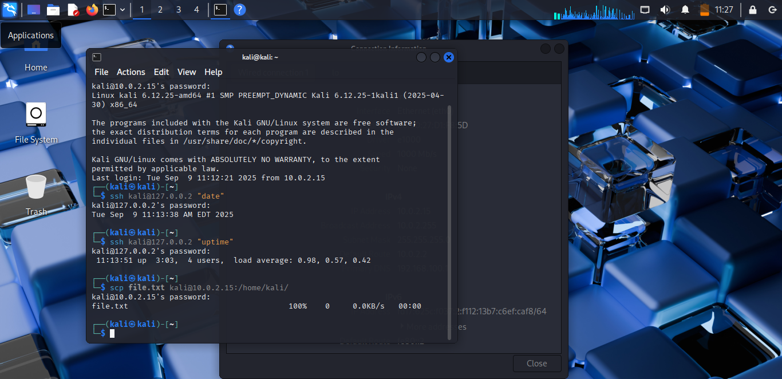

# Task 2

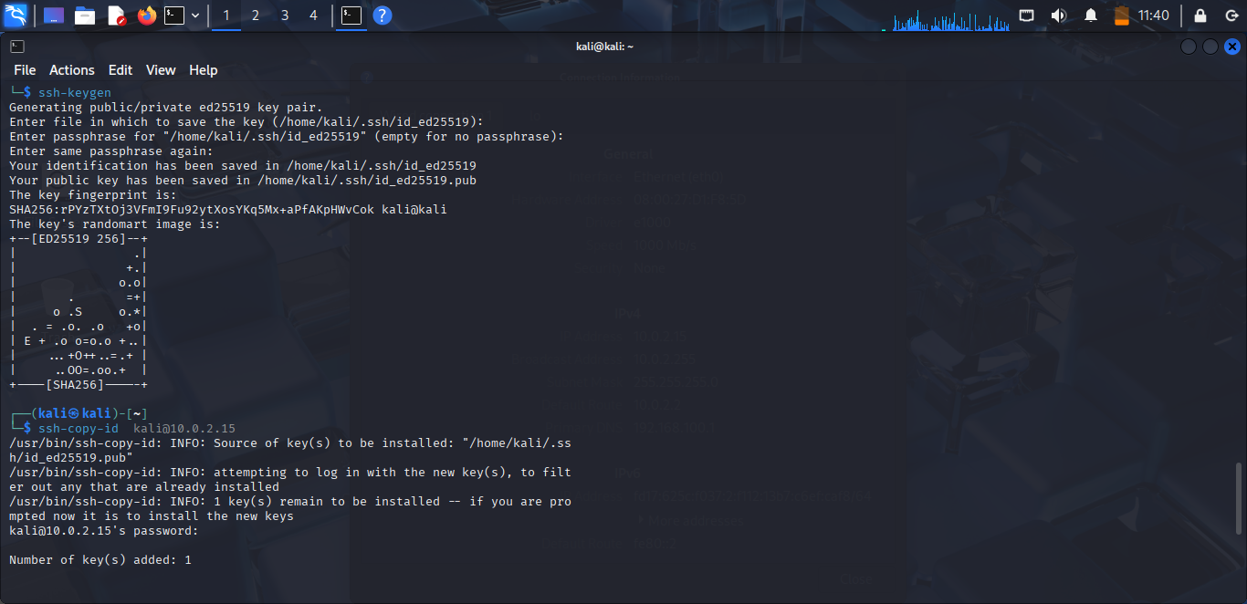

# Task 3

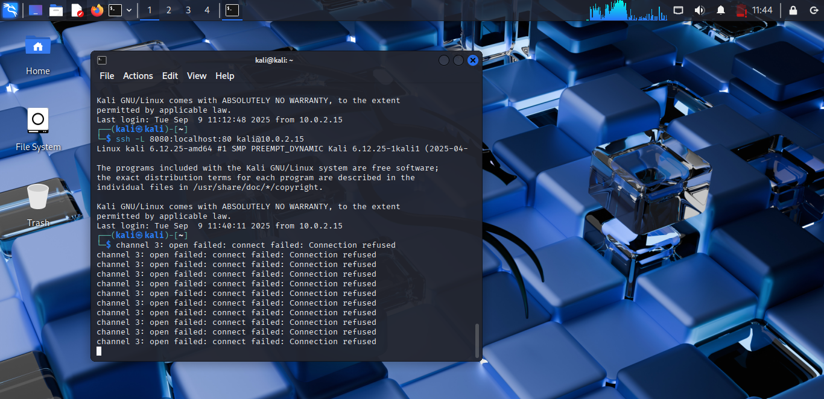

# Task 4

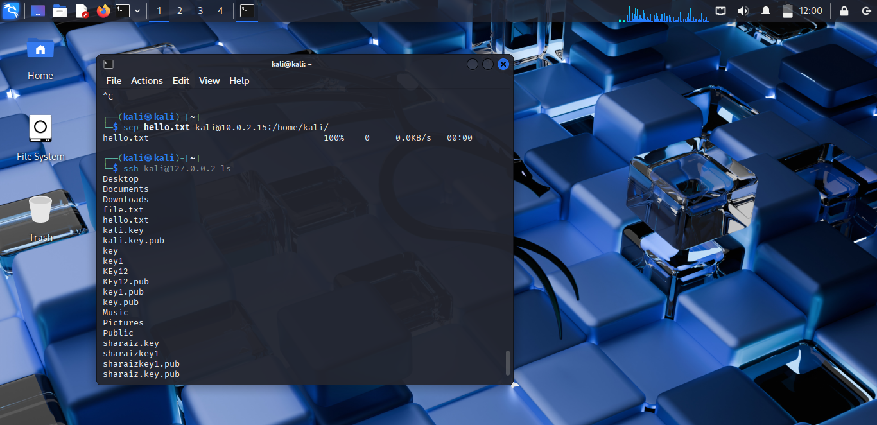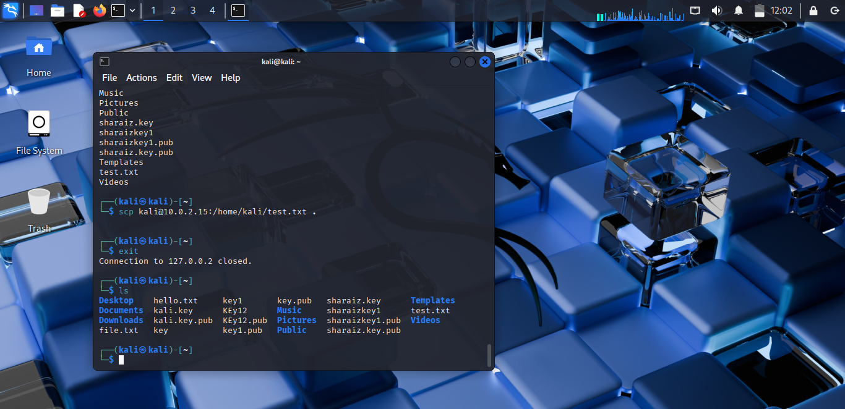

# Task 5

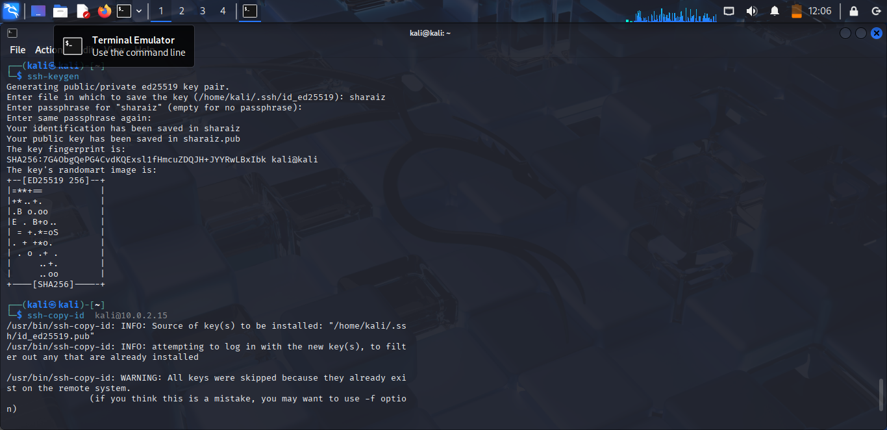

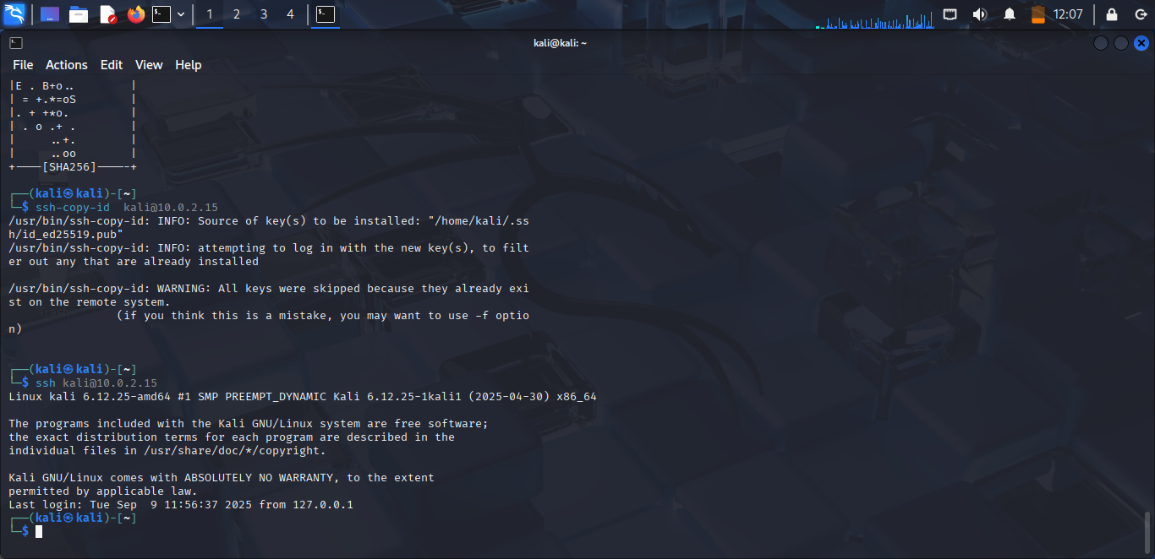

# Task 6

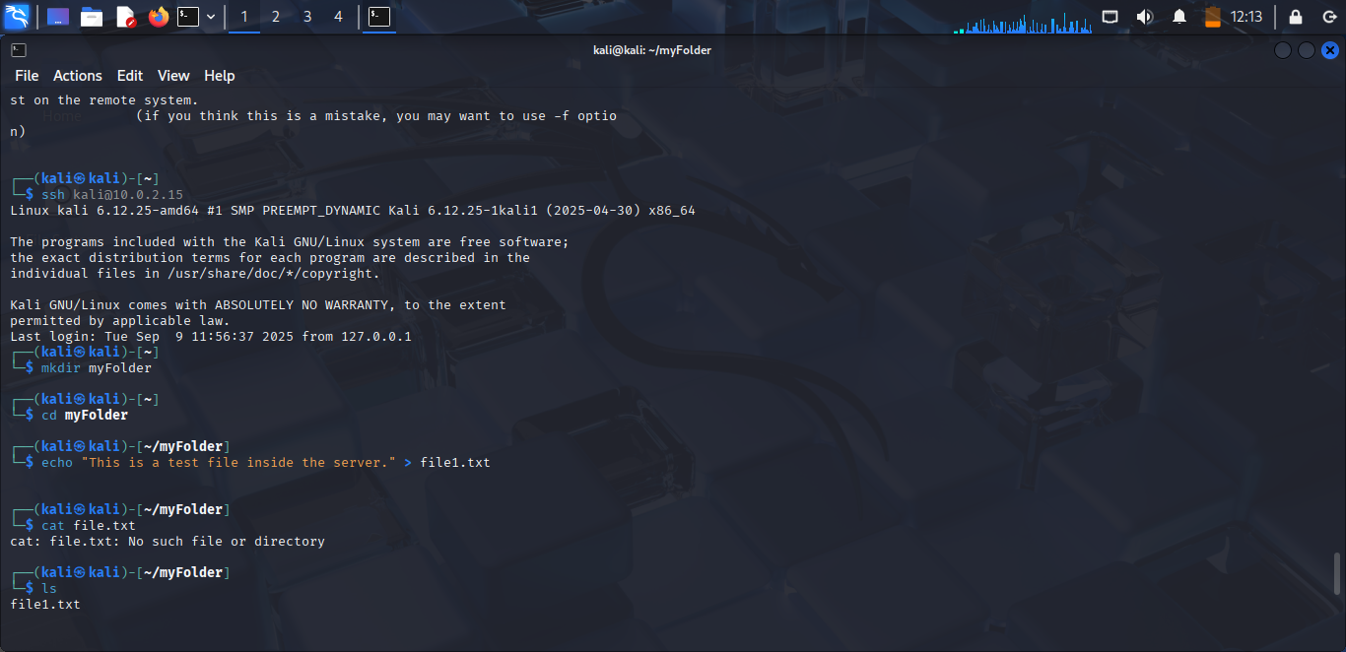

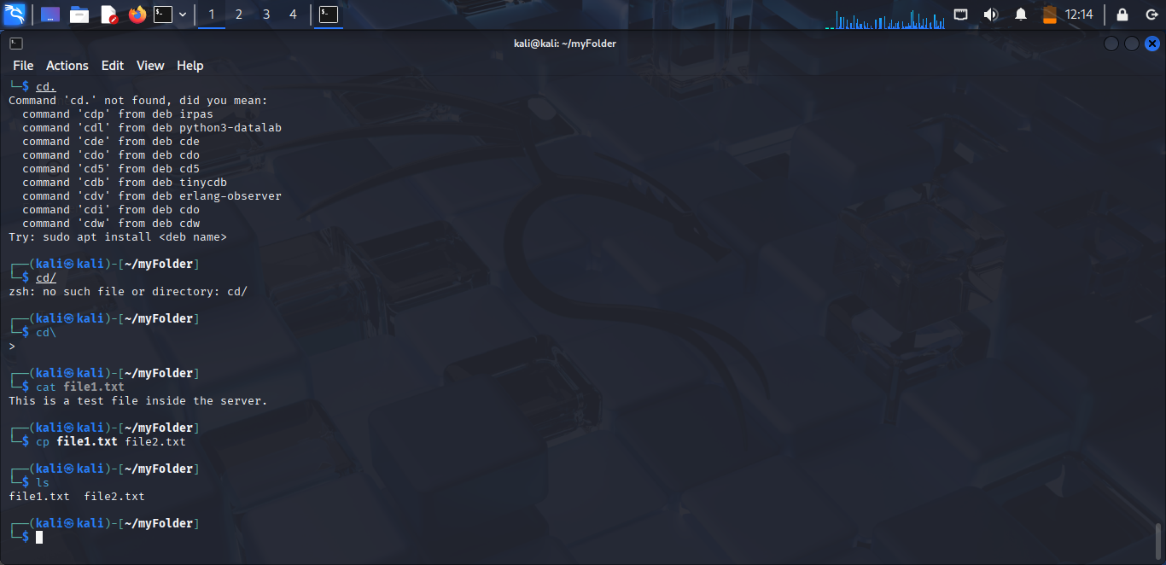

# Task 7

scp kali@10.0.2.15:/home/kali/myFolder/file1.txt kali@10.0.2.15:/home/kali/myFolder/file2.txt [kali@10.0.2.15:/home/kali/myFolder/file3.txt](mailto:kali@10.0.2.15:/home/kali/myFolder/file3.txt)

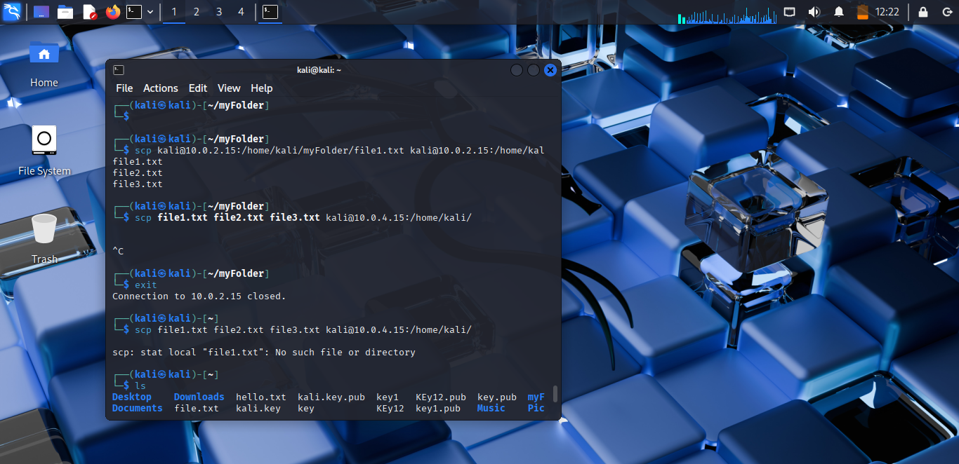

scp file1.txt file2.txt file3.txt [kali@10.0.2.15:/home/kali/](mailto:kali@10.0.2.15:/home/kali/)

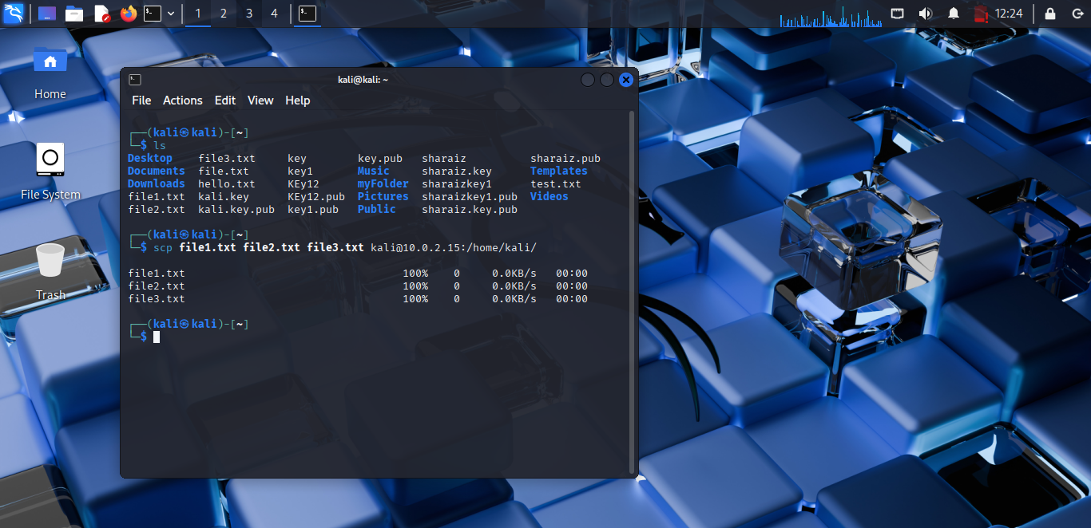

# Task 8

* Generate an SSH key pair on your local machine
* Copy the public key to the server
* Test passwordless login
* Run multiple remote commands in one SSH call
  + ssh kali@10.0.2.15 "whoami; hostname; uptime"

